**3. DATA DICTIORNARY**

**1.University**

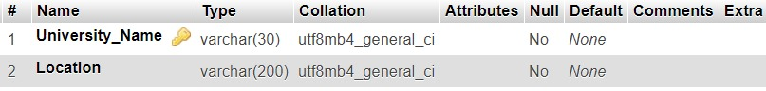

**2.Activity**

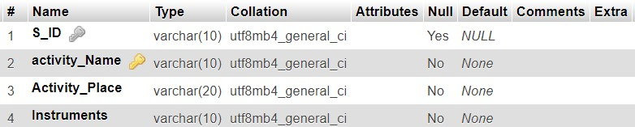

**3.Courses**

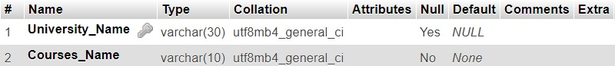

**4.Stationary**

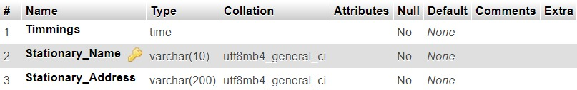

**5.Events**

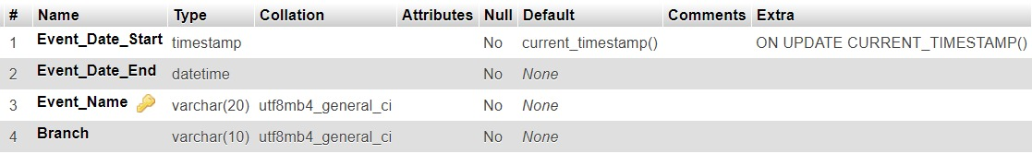

**6.Book**

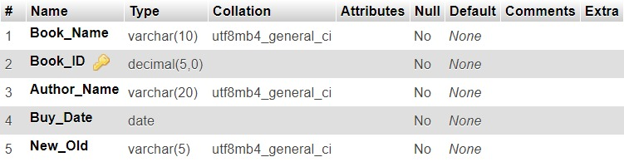

**7.PG_Hostel**

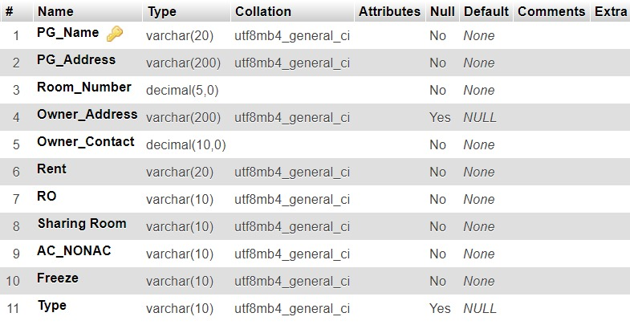

**8.Resturant**

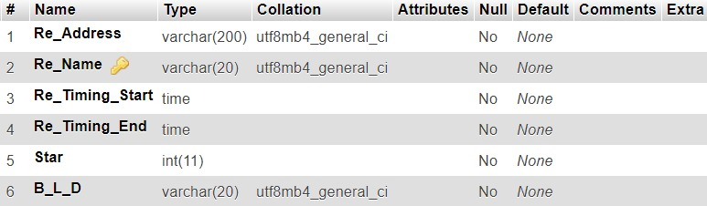

**9.Community**

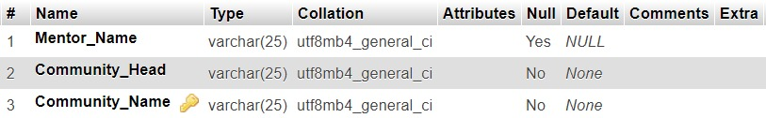

**10.Stationary_Buy**

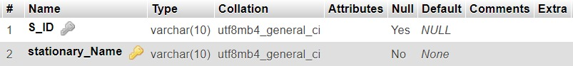

**11.Member**

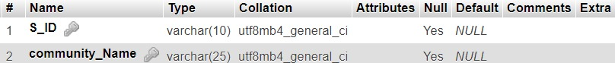

**12.Student**

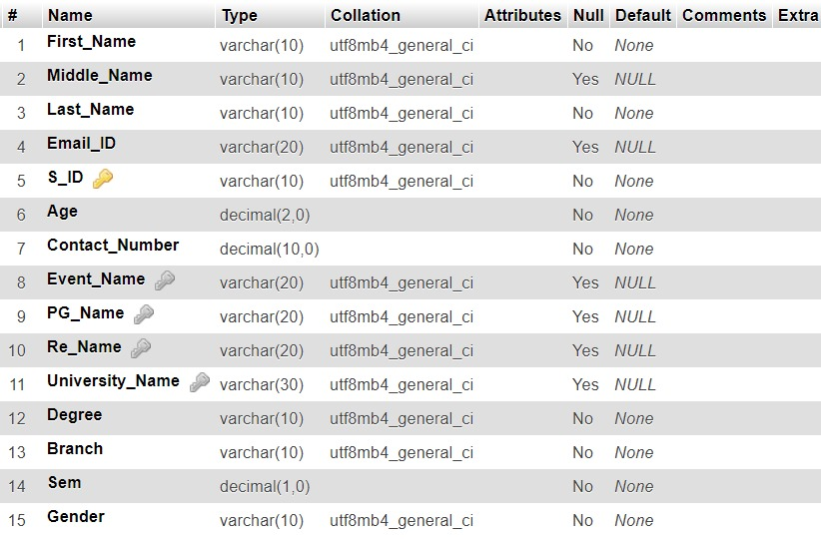

**13.Admin**

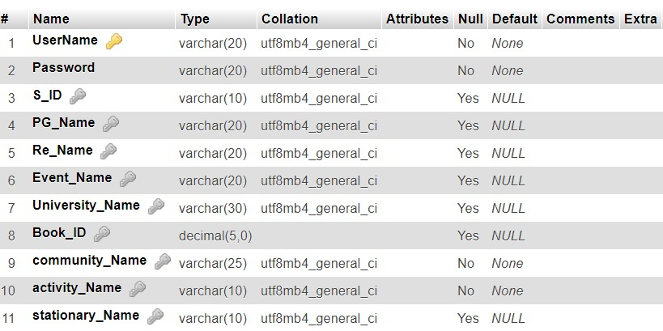

**14.Organize**

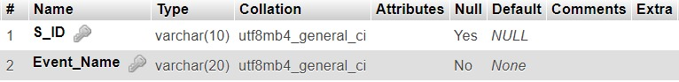

**4.SCHEMA DIAGRAM**

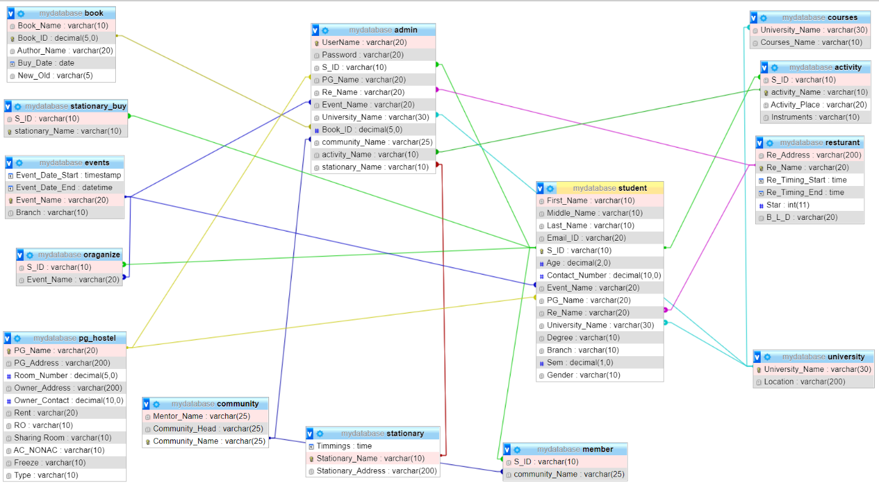

**5.DATABASE IMPLEMENTATION**

**5.1 CREATE SCHEMA**

**1.Student**

CREATE TABLE STUDENT (First_Name VARCHAR(10) NOT NULL, Middle_Name VARCHAR(10) DEFAULT NULL, Last_Name VARCHAR(10) NOT NULL, Email_ID VARCHAR(20) DEFAULT NULL, S_ID VARCHAR(10) PRIMARY KEY, Age DECIMAL(2) NOT NULL, Contact_Number DECIMAL(10) NOT NULL, Event_Name VARCHAR(10), PG_Name VARCHAR(20), Re_Name VARCHAR(10), University_Name VARCHAR(30), Degree VARCHAR(10) NOT NULL, Branch VARCHAR(10) NOT NULL, Sem DECIMAL(1) NOT NULL, Gender VARCHAR(10) NOT NULL);

ALTER TABLE `student` ADD CONSTRAINT `student1` FOREIGN KEY (`Event_Name`) REFERENCES `events` (`Event_Name`);

ALTER T)ABLE `student` ADD CONSTRAINT `student2` FOREIGN KEY (`PG_Name`) REFERENCES `pg_hostel` (`PG_Name`);

ALTER TABLE `student` ADD CONSTRAINT `student3` FOREIGN KEY (`Re_Name`) REFERENCES `resturant` (`Re_Name`);

ALTER TABLE `student` ADD CONSTRAINT `student4` FOREIGN KEY (`University_Name`) REFERENCES `university` (`University_Name`);

**2.community**

CREATE TABLE COMMUNITY (Mentor_Name VARCHAR(25) DEFAULT NULL, Community_Head VARCHAR(25) NOT NULL, Community_Name VARCHAR(25) PRIMARY KEY);

**3.Stationary**

CREATE TABLE STATIONARY (Timmings TIME NOT NULL, Stationary_Name VARCHAR(10) PRIMARY KEY, Stationary_Address VARCHAR(200) NOT NULL);

**4.Event**

CREATE TABLE EVENTS(Event_Date_Start TIMESTAMP NOT NULL, Event_Date_End DATETIME NOT NULL, Event_Name VARCHAR(20) PRIMARY KEY, Branch VARCHAR(10) NOT NULL);

**5.Book**

CREATE TABLE BOOK (Book_Name VARCHAR(10) NOT NULL, Book_ID DECIMAL(5) PRIMARY KEY, Author_Name VARCHAR(20) NOT NULL, Buy_Date DATE NOT NULL, New_Old VARCHAR(5) NOT NULL);

**6.pg_hostel**

CREATE TABLE PG_HOSTEL (PG_Name VARCHAR(20) PRIMARY KEY, PG_Address varchar(200) NOT NULL, Room_Number DECIMAL(5) NOT NULL, Owner_Address VARCHAR(200) DEFAULT NULL, Owner_Contact DECIMAL(10) NOT NULL, Rent VARCHAR(20) NOT NULL, RO VARCHAR(10) NOT NULL, TWO_BHK_3BHK VARCHAR(10) NOT NULL, AC_NONAC VARCHAR(10) NOT NULL, Freeze VARCHAR(10) NOT NULL, Type VARCHAR(10) NOT NULL);

**7.Restaurant**

CREATE TABLE Resturant (Re_Address VARCHAR(200) NOT NULL, Re_Name VARCHAR(20) PRIMARY KEY, Re_Timing_Start TIME NOT NULL, Re_Timing_End TIME NOT NULL, Star INT NOT NULL, B_L_D VARCHAR(20) NOT NULL);

**8.Admin**

CREATE TABLE ADMIN (UserName VARCHAR(20) PRIMARY KEY, Password VARCHAR(20) NOT NULL, S_ID VARCHAR(10), PG_Name VARCHAR(20), Re_Name VARCHAR(20), Event_Name VARCHAR(20), University_Name VARCHAR(10), Book_ID DECIMAL(5), community_Head VARCHAR(10) NOT NULL, Acitvity_Name VARCHAR(10) NOT NULL, stationary_Name VARCHAR(10))

ALTER TABLE `admin` ADD CONSTRAINT `amin1213` FOREIGN KEY (`stationary_Name`) REFERENCES `stationary` (`stationary_Name`)

ALTER TABLE `admin` ADD CONSTRAINT `amin12` FOREIGN KEY (`PG_Name`) REFERENCES `pg_hostel` (`PG_Name`)

ALTER TABLE `admin` ADD CONSTRAINT `amin12134` FOREIGN KEY (`Re_Name`) REFERENCES `restaurant` (`Re_Name`)

ALTER TABLE `admin` ADD CONSTRAINT `amin121345` FOREIGN KEY (`Event_Name`) REFERENCES `events` (`Event_Name`)

ALTER TABLE `admin` ADD CONSTRAINT `amin1213456` FOREIGN KEY (`University_Name`) REFERENCES `University` (`University_Name`)

ALTER TABLE `admin` ADD CONSTRAINT `amin14567` FOREIGN KEY (`Book_ID`) REFERENCES `Book’ (`Book_ID`)

ALTER TABLE `admin` ADD CONSTRAINT `amin14567` FOREIGN KEY (`community_Name`) REFERENCES `community` (`community_Name`)

ALTER TABLE `admin` ADD CONSTRAINT `amin1288` FOREIGN KEY (`activity_Name`) REFERENCES `Activity` (`activity_Name`)

ALTER TABLE `admin` ADD CONSTRAINT `amin1457` FOREIGN KEY (`S_ID`) REFERENCES `student` (`S_ID`)

**9.Stationary_Buy**

CREATE TABLE stationary_Buy (S_ID VARCHAR(10), stationary_Name VARCHAR(10) PRIMARY KEY)

ALTER TABLE `stationary_buy` ADD CONSTRAINT `sb` FOREIGN KEY (`S_ID`) REFERENCES `student` (`S_ID`)

**10.Member**

CREATE TABLE member (S_ID VARCHAR(10),community_Name VARCHAR(25));

ALTER TABLE `member` ADD CONSTRAINT `m2` FOREIGN KEY (`S_ID`) REFERENCES `student` (`S_ID`);

ALTER TABLE `member` ADD CONSTRAINT `m3` FOREIGN KEY (`community_Name`) REFERENCES `community` (`community_Name`);

**11.University**

CREATE TABLE University (University_Name VARCHAR(30) PRIMARY KEY, Location VARCHAR(200) NOT NULL)

**12.Courses**

CREATE TABLE Courses (University_Name VARCHAR(30), Courses_Name VARCHAR(10) NOT NULL)

ALTER TABLE `courses` ADD CONSTRAINT `COURSES` FOREIGN KEY (`University_Name`) REFERENCES `university` (`University_Name`)

**13.Activity**

CREATE TABLE Activity (S_ID VARCHAR(10), Activity_Name VARCHAR(10) PRIMARY KEY, Activity_Place VARCHAR(20) NOT NULL, Instruments VARCHAR(10) NOT NULL)

ALTER TABLE `activity` ADD CONSTRAINT `amin1457` FOREIGN KEY (`S_ID`) REFERENCES `student` (`S_ID`)

**14.Organize**

CREATE TABLE Oraganize(S_ID VARCHAR(10), Event_Name VARCHAR(10) PRIMARY KEY)

ALTER TABLE `organize` ADD CONSTRAINT `or` FOREIGN KEY (`S_ID`) REFERENCES `student` (`S_ID`)

**5.2 INSERT DATA VALUE**

**1.Student**

INSERT INTO `student`(`First_Name`, `Middle_Name`, `Last_Name`, `Email_ID`, `S_ID`, `Age`, `Contact_Number`, `Event_Name`, `PG_Name`, `Re_Name`, `University_Name`, `Degree`, `Branch`, `Sem`) VALUES ('Dishant','H','Modh','dishant@gmail.com','1', 18, 9512100731,'BreakUp Day','Royal Care','Prime Dinning Hall','Dharmsinh Desai','B.Tech','IT',5,’Male’ );

INSERT INTO `student`VALUES ('Twiency','','Korat','trkorat76@gmail.com','2', 18, 9428666531,'Coding war','Blossom','Hotel Vandan','IIT-Gandhinagar','B.Tech','CSE',5,'Female');

INSERT INTO `student`VALUES ('Divyesh','D','Chotaliya','dc2310@gmail.com','3', 17, 6356275041,'Cycle Marathon','Shakti','Law Canteen','Nirma','B.Tech','CS',7,'Male' );

INSERT INTO `student` VALUES ('Jay','','Panchal','jaypanchal@gmail.com','4', 22, 9586986565,'Falicific','Aarav Hostel','Panihari restaurant','GMIT','B.Tech','IT',1 ,'Male');

INSERT INTO `student`VALUES ('Shivani','K','Modi','shivanimodi@gmail.com','5', 19, 7889455622,'Photography','Samaras','Virat fast-food','DaIICT','B.Tech','ICT',3,'Female' );

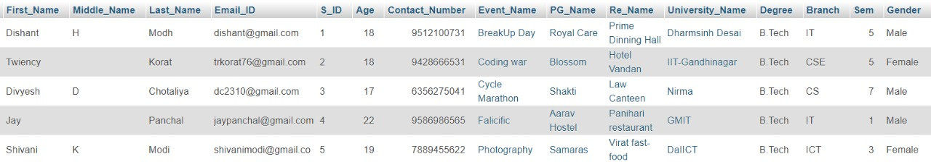

**2.Community**

**3.Stationary**